User Options

## Measuring units

Distance and height have their own options allowing you to have distance in miles and heights in metres.

## Starter List

The various registration/manage/calculator forms show a list with the number of starters a specific period either side of your start time. By default this is 24hrs but this option lets you modify that.

## Membership List Fields

The various lists on the records page - “*fastest times*”, “*youngest women*”, etc. have predefined sets of columns that make sense for that particular list - there’s no point in displaying the gender column for “*youngest women*” since everyone listed will be female.

The Membership List table is different in that the set of columns is fixed to:

**“Member #”, “Name”, “Age”, “Gender”, “Date of Round”, “Time”, “Direction”, “Route Option”, “Attempts”**

Which has been chosen as the set that people are most likely to be interested in when looking at the filtered data. But, that’s not to say it’s right for everyone or for every search.

With the new search facility allowing much more variety in how the list of members is filtered and sorted that set may not be the optimum and you may wish to define your own. There is no reasonable limit to the number of such sets you may define and you can define separate lists of such sets for both desktop and mobile where there’s less screen width available. When searching the membership list there’s a dropdown list in the “Display Options” section to select which column set you wish to use.

Two lists are displayed on the Options page: that on the left shows the columns in the current list (this will be explained in a moment); that on the right shows the remaining columns that may be added.

The initial “current list” is that listed above and is referred in this document and on the options and search pages as “**system**”. Changes to this cannot be saved so when you make changes you have to give the updated list a new name. The names used are quite important as the code follows some rules when figuring out which list to use.

* + - * If there is a list named “**default**” then this is selected as the set to use.
      * Otherwise select the “**system**” set.
      * If the user selects a different set, use that.

A couple of examples should clarify things…

Let’s say there are the following sets saved in the desktop list

system

default <—

my_club

my_postcode

In this instance the code will load your “**default**” set unless you choose one of the others.

system <—

my_club

my_postcode

Here the code will load the “system” set unless you choose one of the other sets.

Therefore if you have a set of columns that you want to use regularly call it “**default**” so the code does a bit of work for you.

Initially the only list available for either desktop or mobile is “**system**” (they are different), we’ll go with desktop for this work-through but the steps are the same for mobile, so the contents of that set are displayed in the left list and the remaining available columns in the right list.

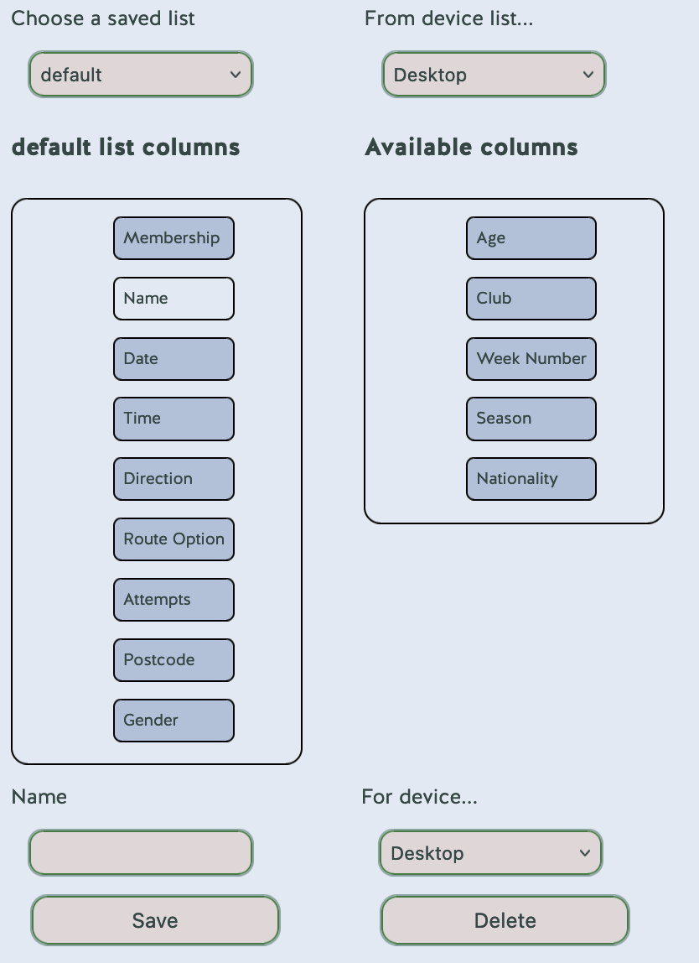

Drag columns between the two lists until you have the set you want. You can also put the columns into whatever order you prefer. Move to the “*Name*” input box and enter a suitable name for your list - this may be up to 15 characters (a to z, digits, space and hyphen allowed) long. We’ll assume you go with “**default**” so that it is used automatically. Choose the device type (Desktop or Mobile), we’ll leave as Desktop, and click the Save button.

Your new list will be added to the saved lists so you can now select it from the “*Choose a Saved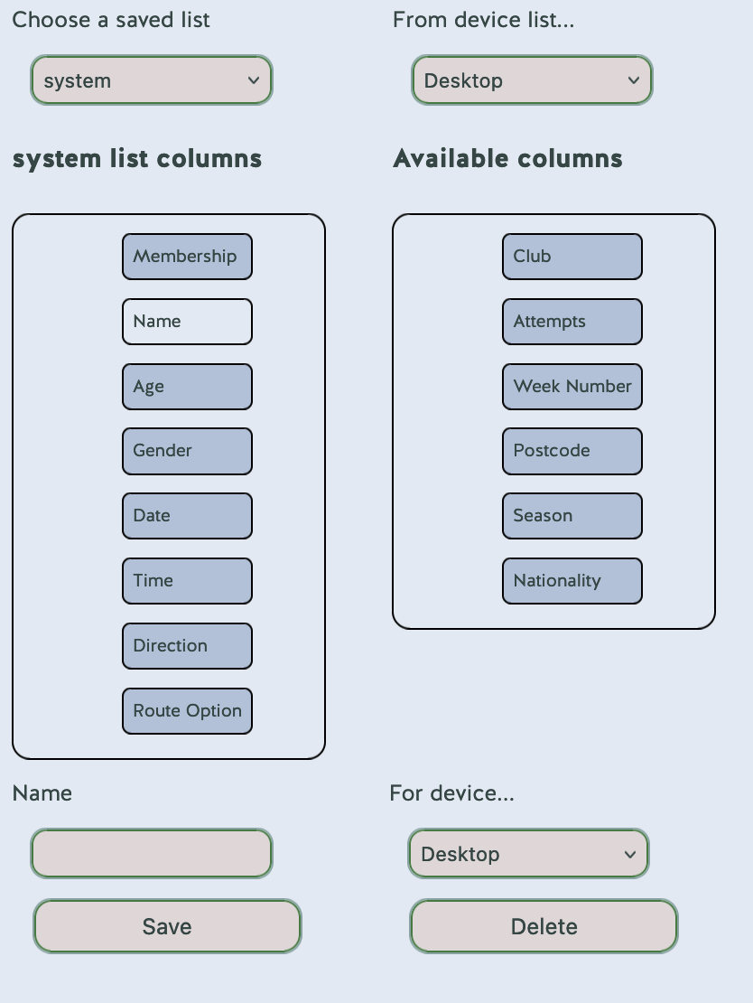 List*” dropdown. It’s worth swapping between “**system**” and whatever you called your set to see that the two lists update.

To create another set you may choose any existing set as a starting point. To update one of your lists, make changes and save it with the same name.

To delete one of **your** lists (you can’t delete the “**system**” list), select it from the “*Choose a saved list*” dropdown and click the “*Delete*” button. If you try to delete a list that is used in one or more saved searches then a dialog will appear stating that you can’t delete it.

## Charting Colours

By default, the graphs use the body background colour as the base colour. Depending on the graph either a set of differing shades of this colour or a set of steps around the colour wheel.

If the default colour(s) aren’t to your taste then select a colour via the picker. The table below the picker shows two sets of colour swatches, one is the colour wheel, the other is the different shades.

There are two slider controls. One controls the difference between the colours in the left hand swatch set, the other controls the steps between each shade in the right hand swatch set.

Once you have selected your colours you may also decide which of the two sets should apply to each chart type (the A vs B chart is fixed to the first and fifth colours).

## Synchronisation

This information along with the registration/calculator data is also stored on the server in a file specific to each user so when you login to the site on another computer/device/browser the code loads your settings to that setup. This means you don’t have to do the setup on every device you use.

The synchronisation code is slightly naive in that it’s simply the last device to update the data on the server that wins so it’s possible to overwrite changes but it generally does what is expected. For security your email is not saved to the server.